Capital C Site Network Load Balancing and ARR configuration

# Architecture

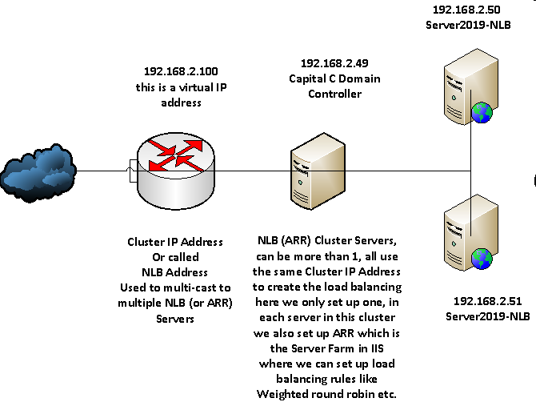

# NLB Configuration

Mainly in Capital C Domain Controller:

* Add Roles and Features 🡪 Network Load Balancing
* Network Loading Balancing Manager 🡪 Add Cluster
* If just use NLB, you can add multiple Cluster IP addresses and each one serves as a load balancing web server; you can also add multiple Cluster IP addresses and each one serves as an ARR server (Application Request Routing)

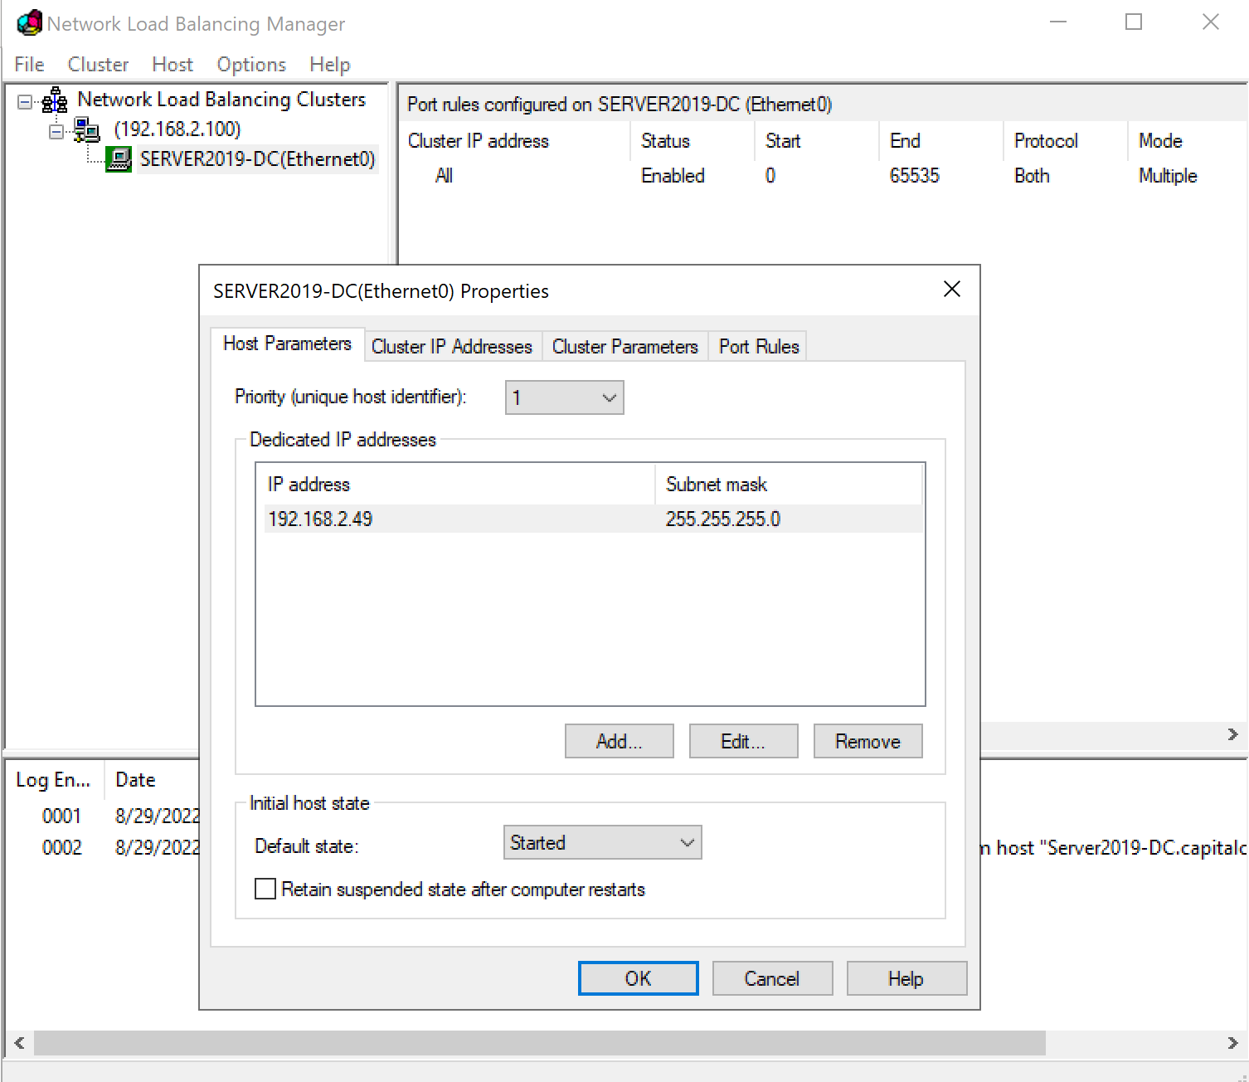

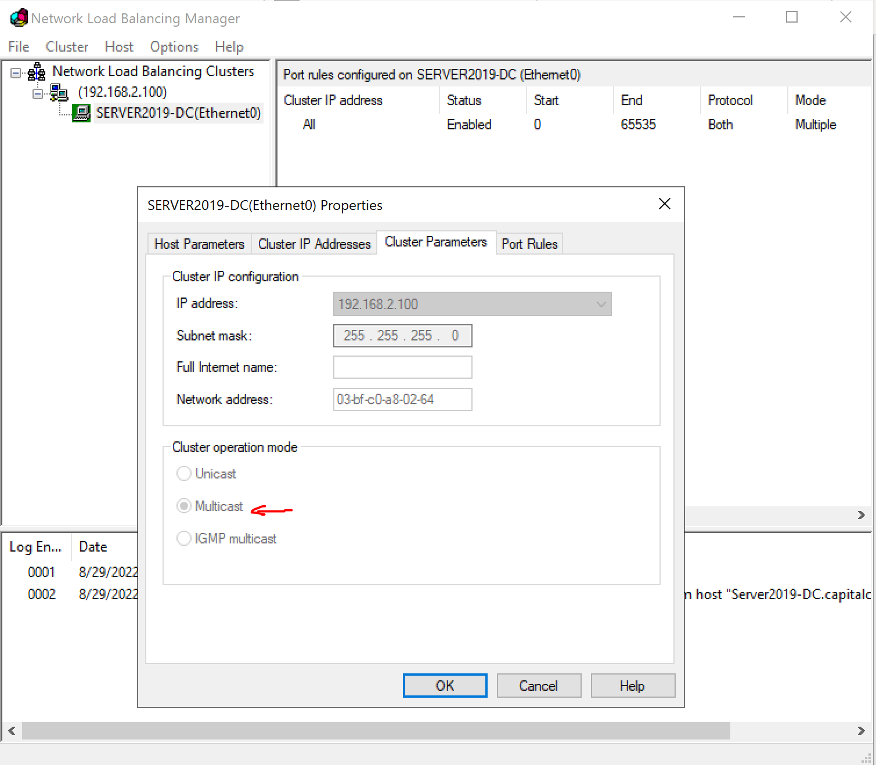

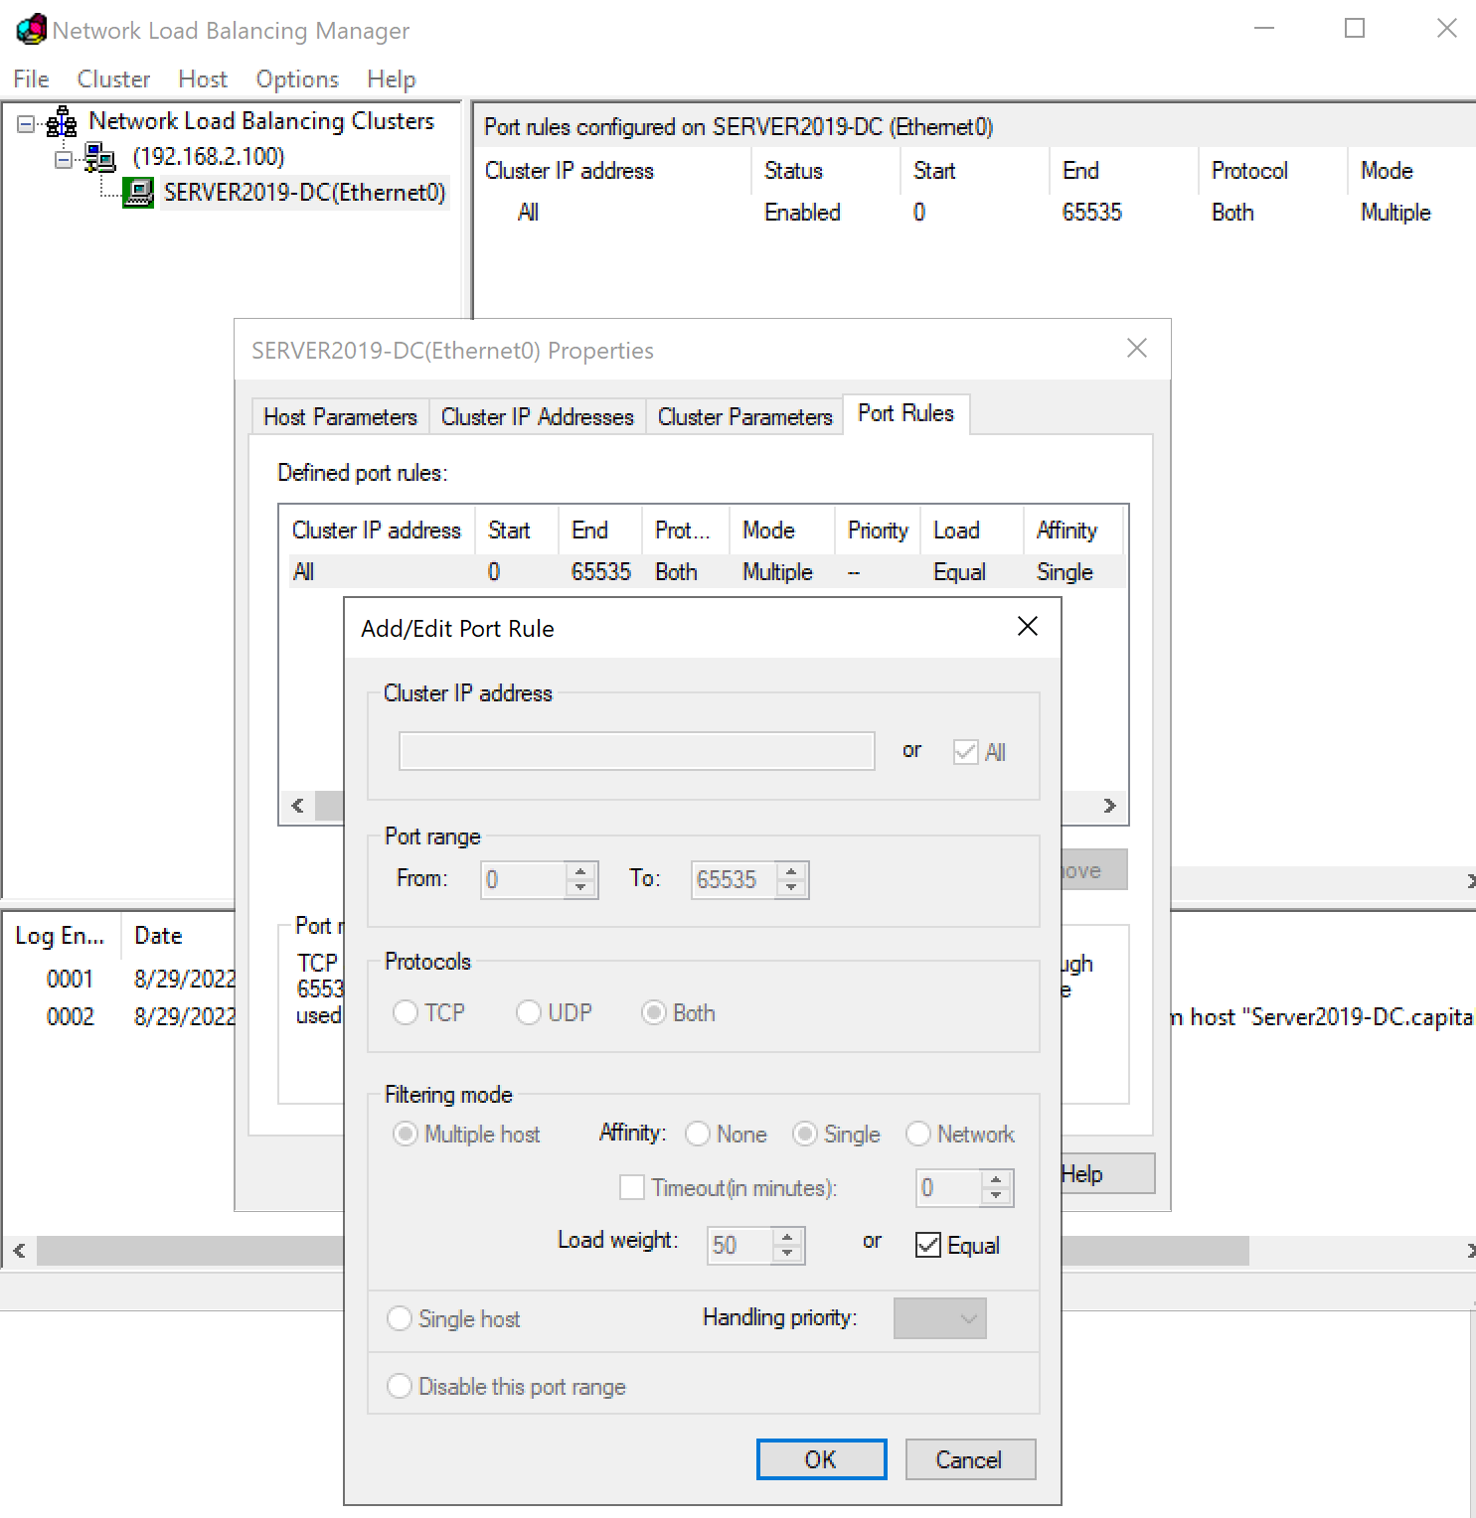

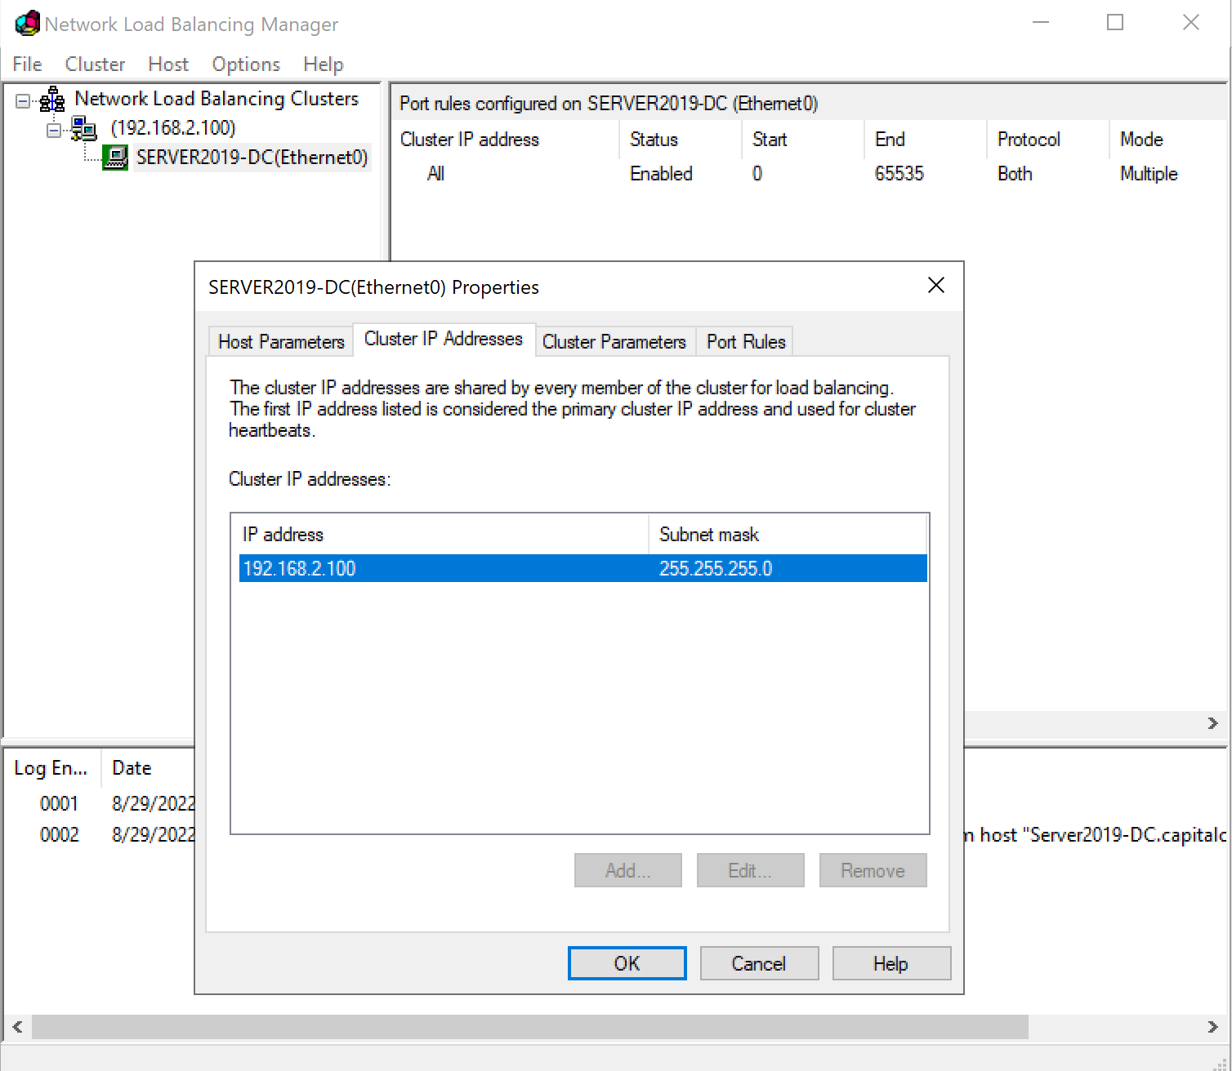

# ARR (Application Request Routing) Configuration

* Launch the Web Platform Installer, and do a search for URL > Select URL Rewrite > Add > Repeat the process, searching for ARR, and add Application Request Routing version 3, (Not the 2.5 version at the top!) > Next > Follow the wizard and complete the install.
* Open Internet Information Services (IIS) Manager 🡪 Server Farms 🡪 Create Server Farms 🡪 Add 2 Load Balancing and Fail Over web servers

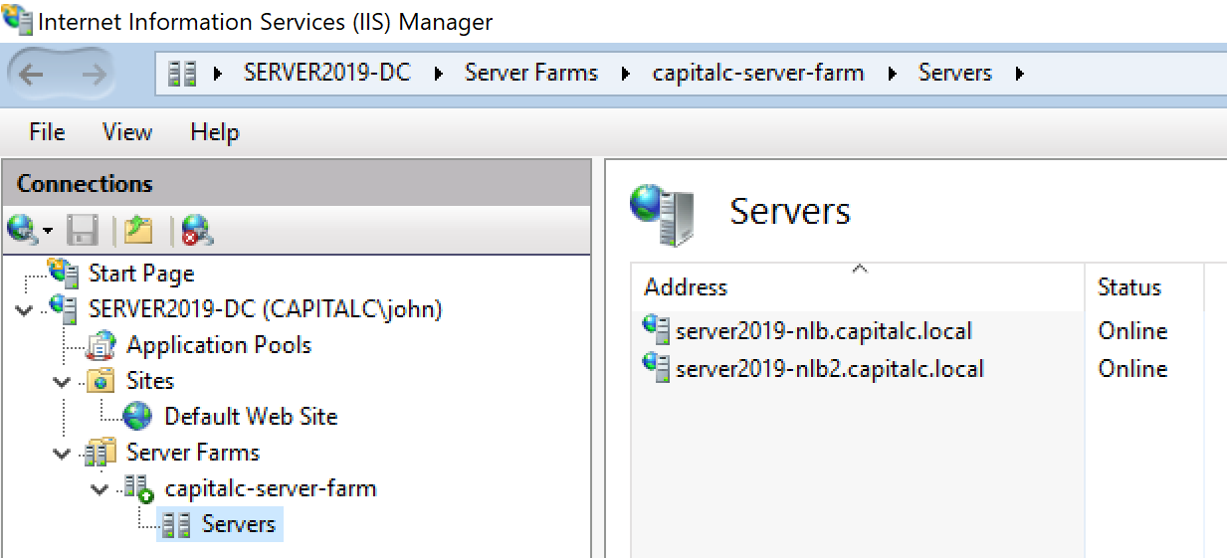

You can manage Fail Over by taking server online/offline

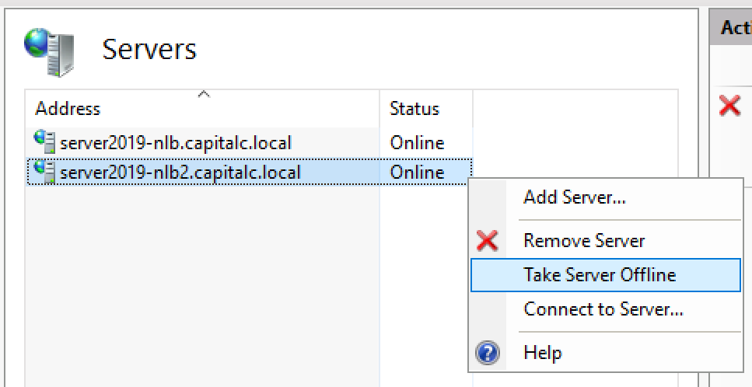

You can also manage the Load Balancing and Routing Rules

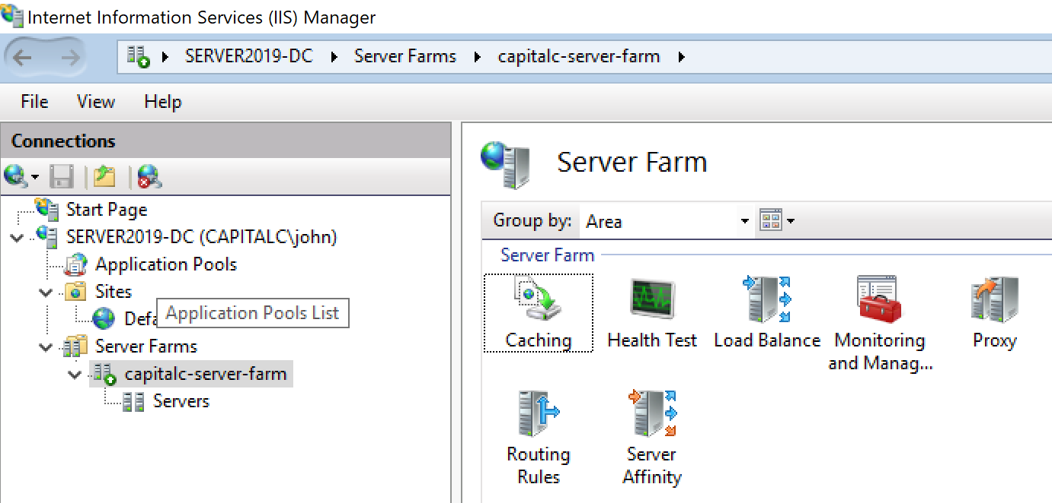

# Install SSL

* Certificate Authority works like a tree, to set up the local Domain Certificate we need to create the root Domain Certificate first.
* Domain Certificate Authority

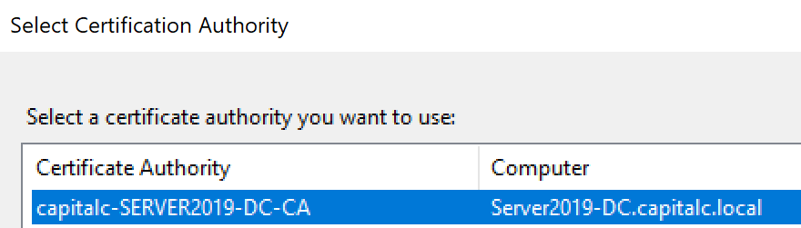

Domain Certificate Authority use its own certificate private key to sign incoming new certificate request issued by the Domain CA.

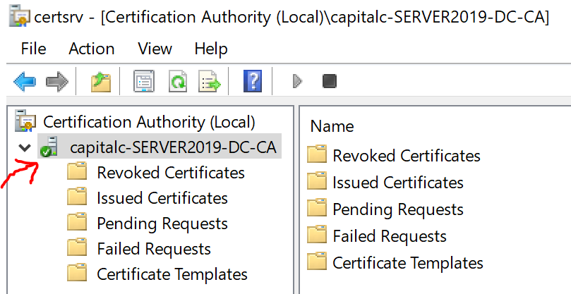

* Certificate Request can be generated by Internet Information Server (IIS) Manager 🡪 Server 🡪 Server Certificates, but this does not work with Microsoft’s Domain CA due to formatting issue.

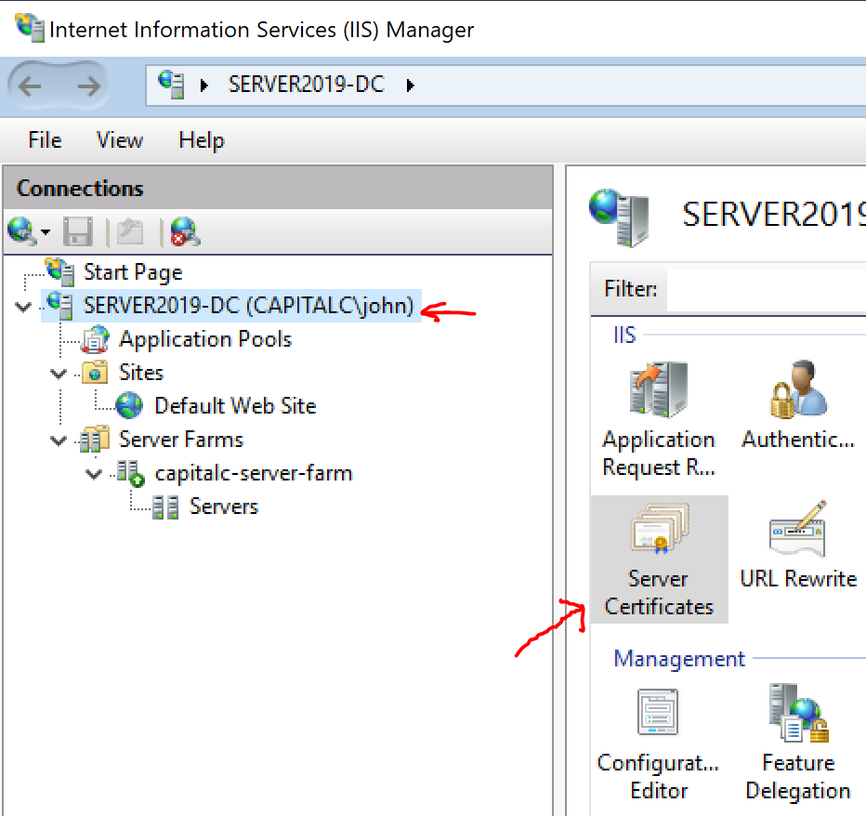

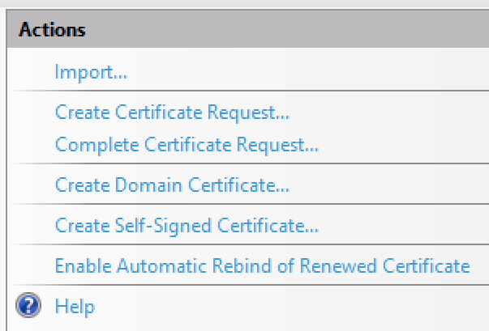

* Create a Web Server Certificate Request

Open Manage computer certificates by typing “certificate” in lookup

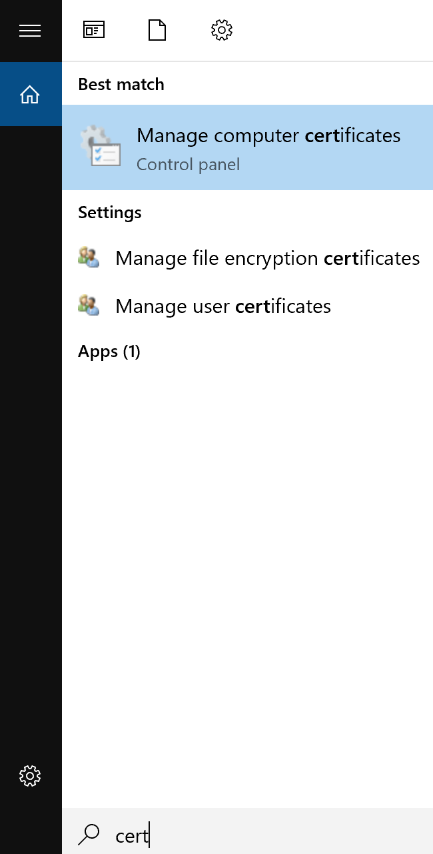

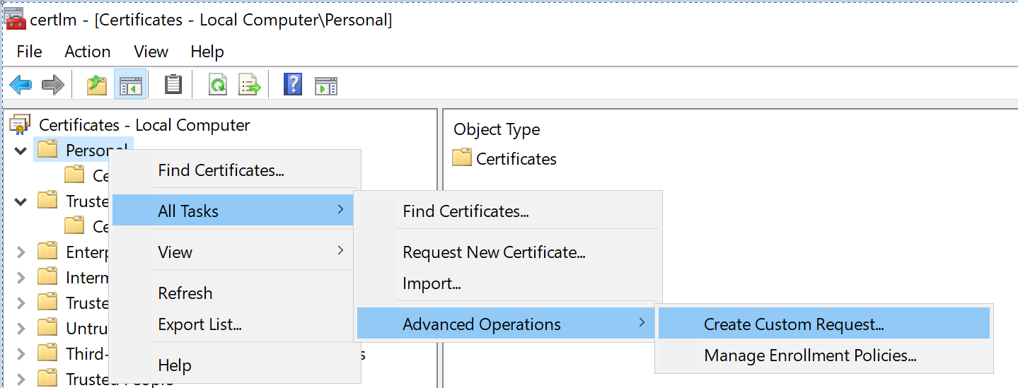

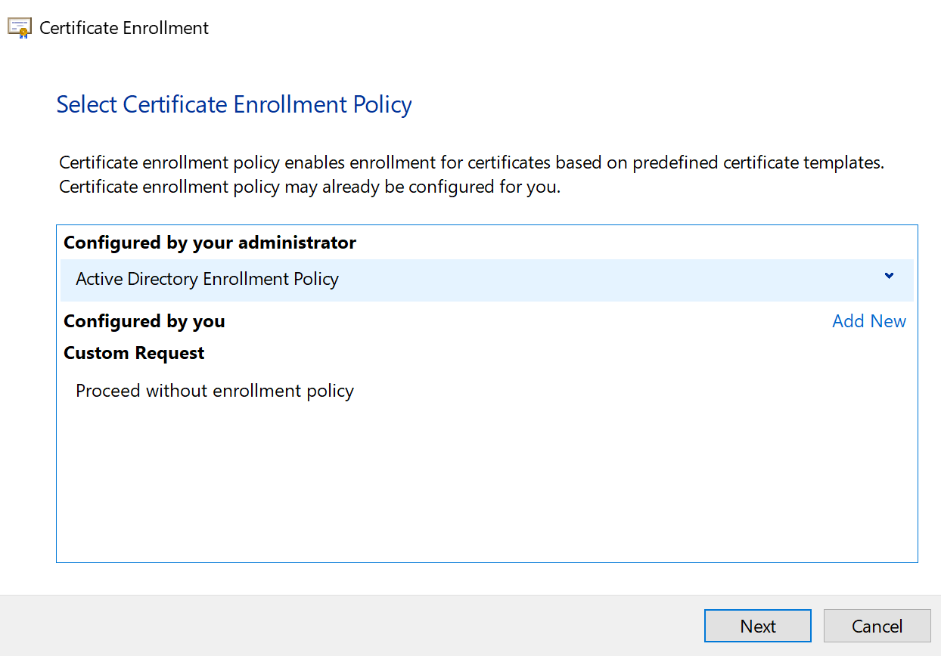

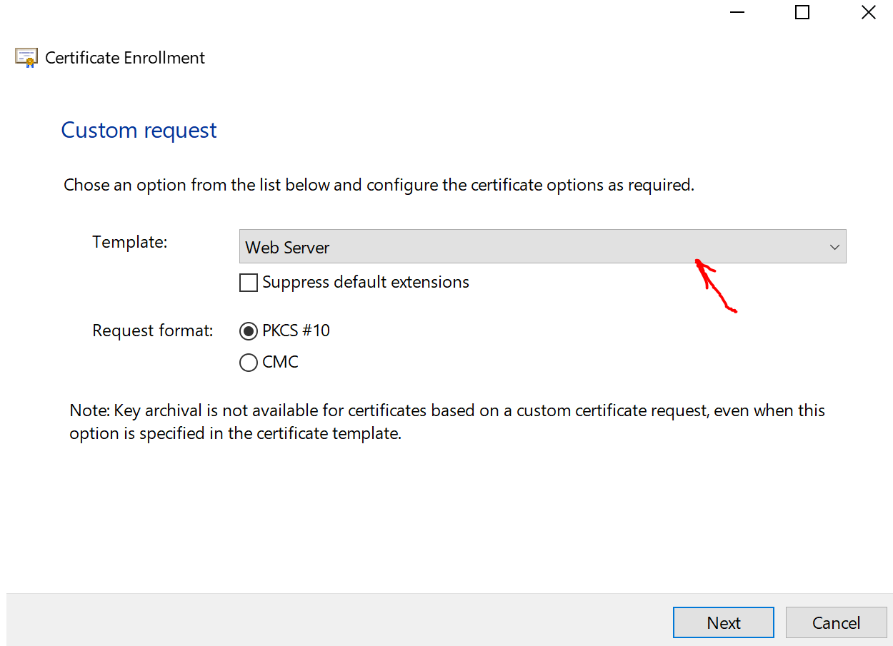

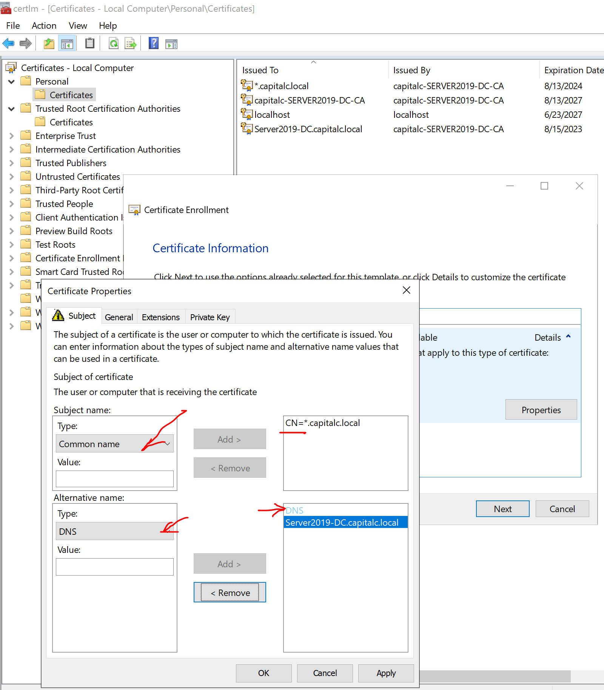

Open Certificate Authority 🡪 Submit new request 🡪 select the *.req file created by previous steps

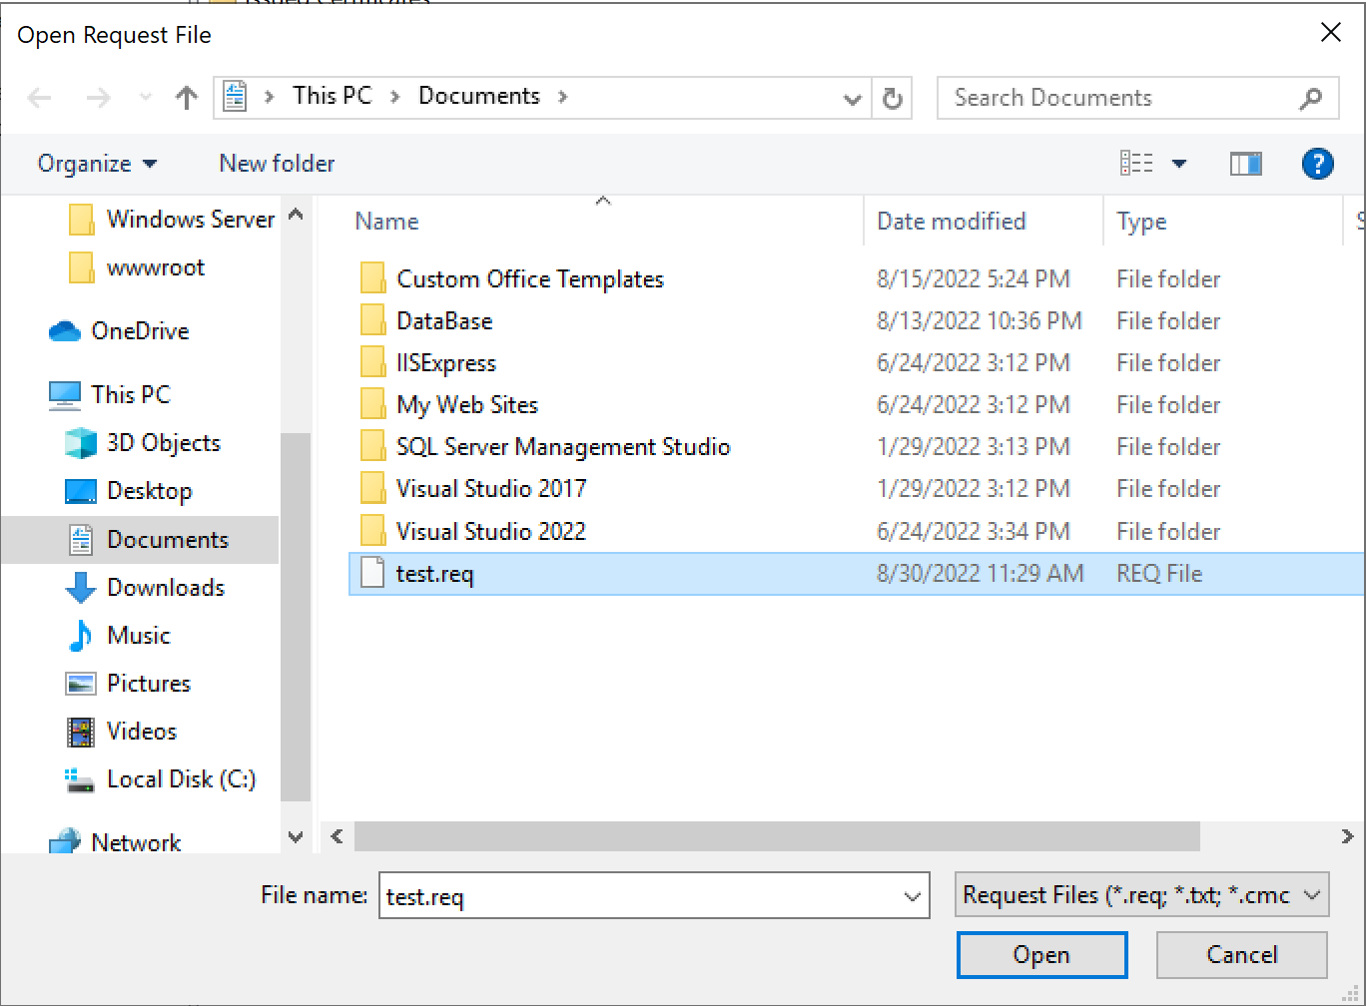

Once request completed it will ask you to save the generated certificate:

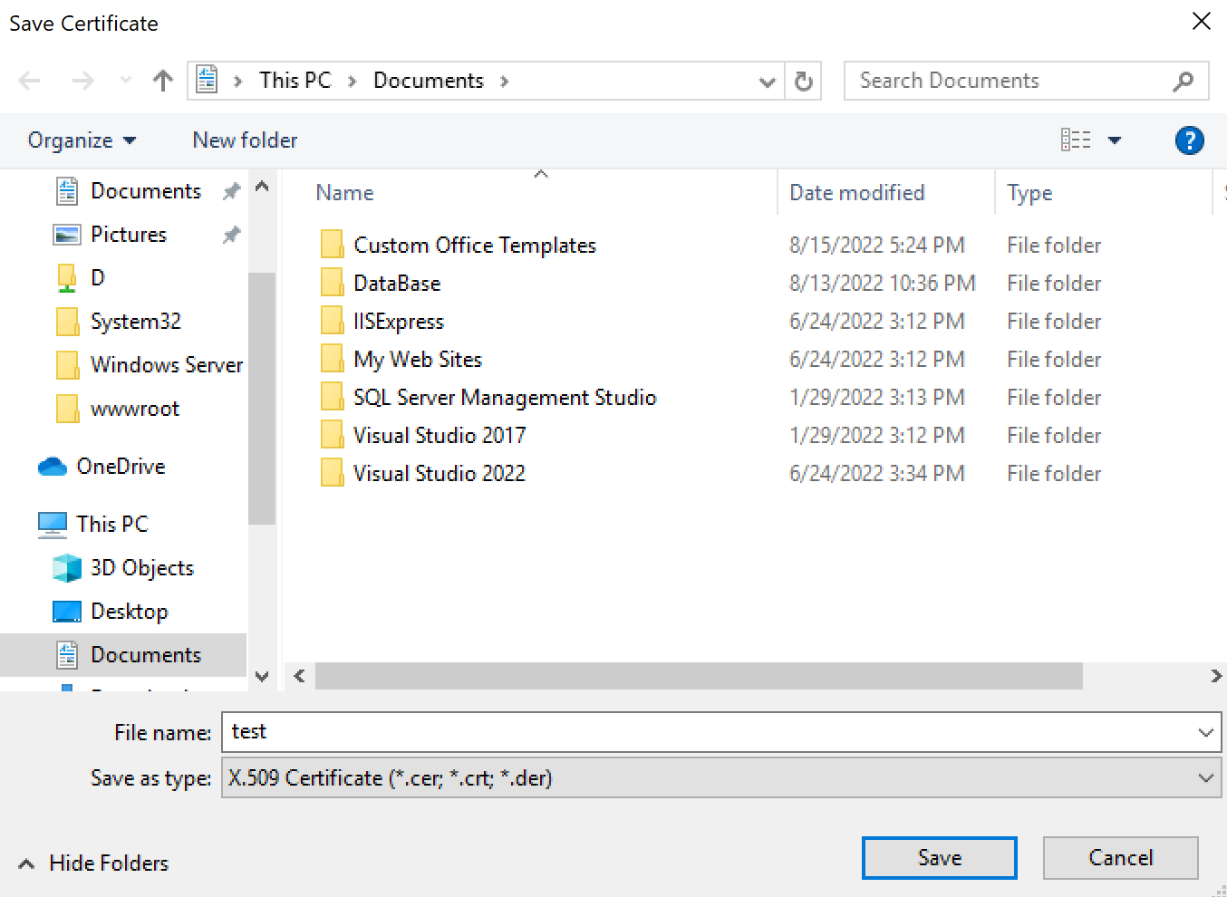

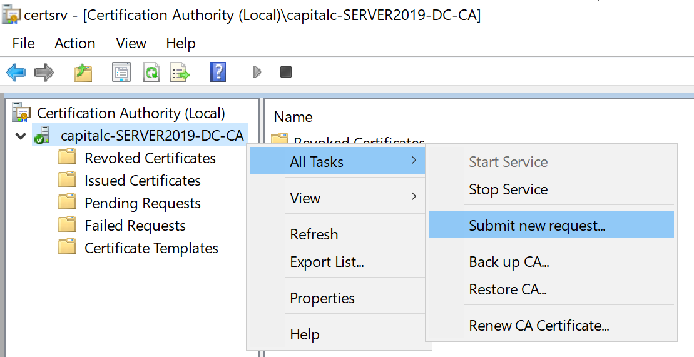

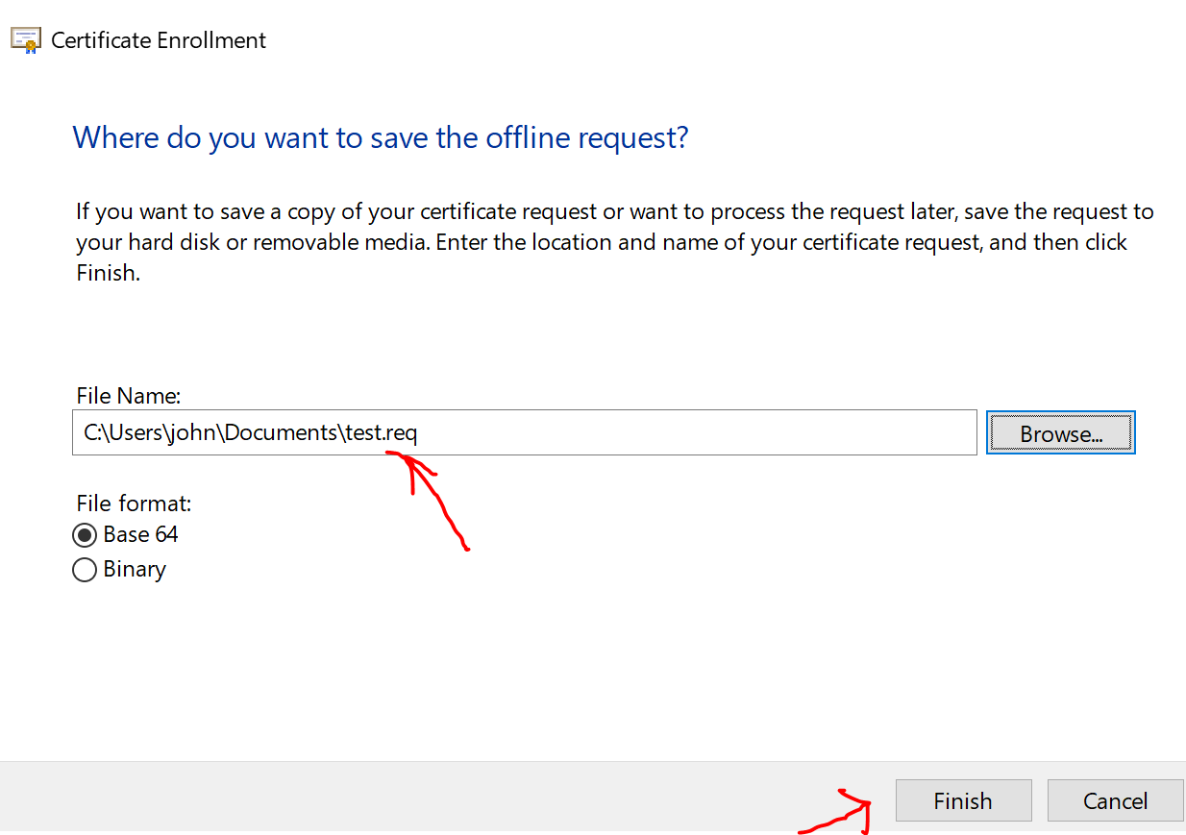

You can see the newly generated web server certificate appear in Issued Certificates list in Certification Authority application:

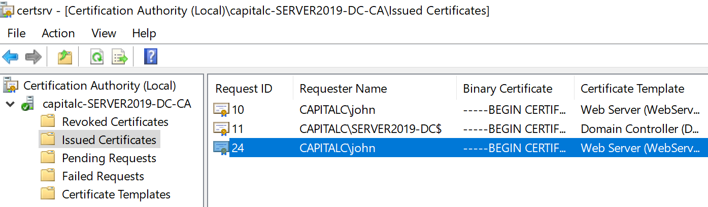

Here we can export the binanary *.cer file from certsrv.

CER File Format 1 The PKC S#7 comprise Base64 ASCII encoding 2 Its file extensions are p7b or p7cZ 3 For binary content, the certificate would be DER or pkcs12/pfx.

* Install web server certificate to IIS web site

Import the generated web site certificate to MMC

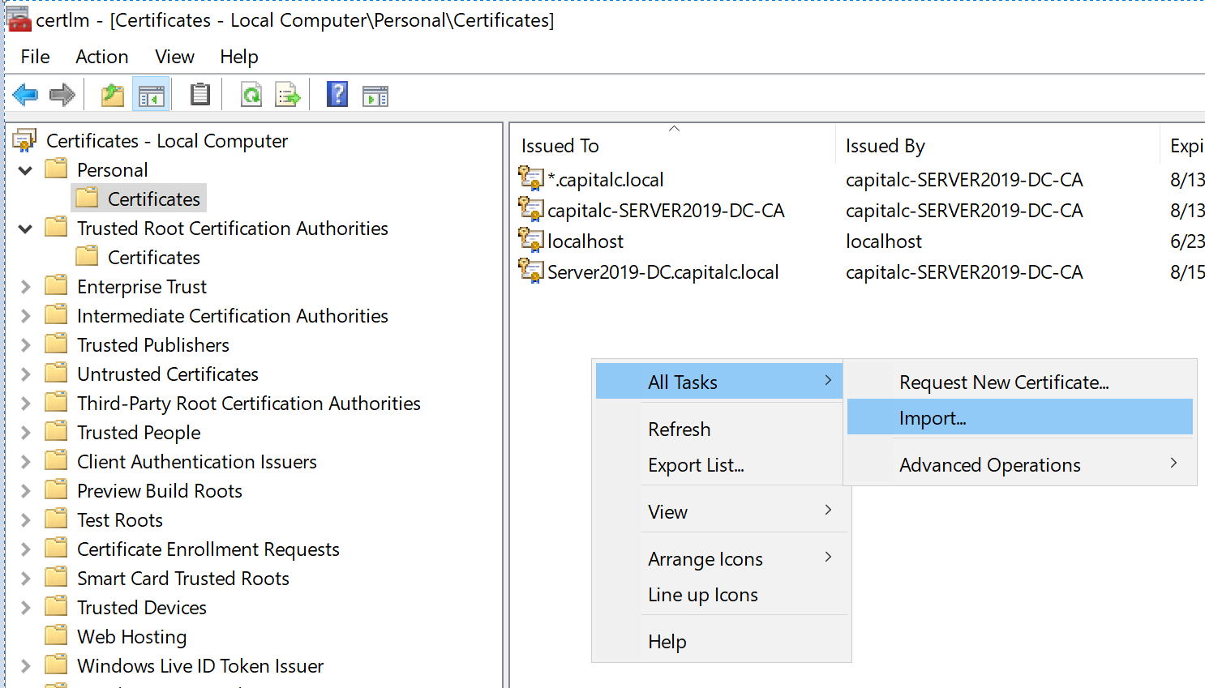

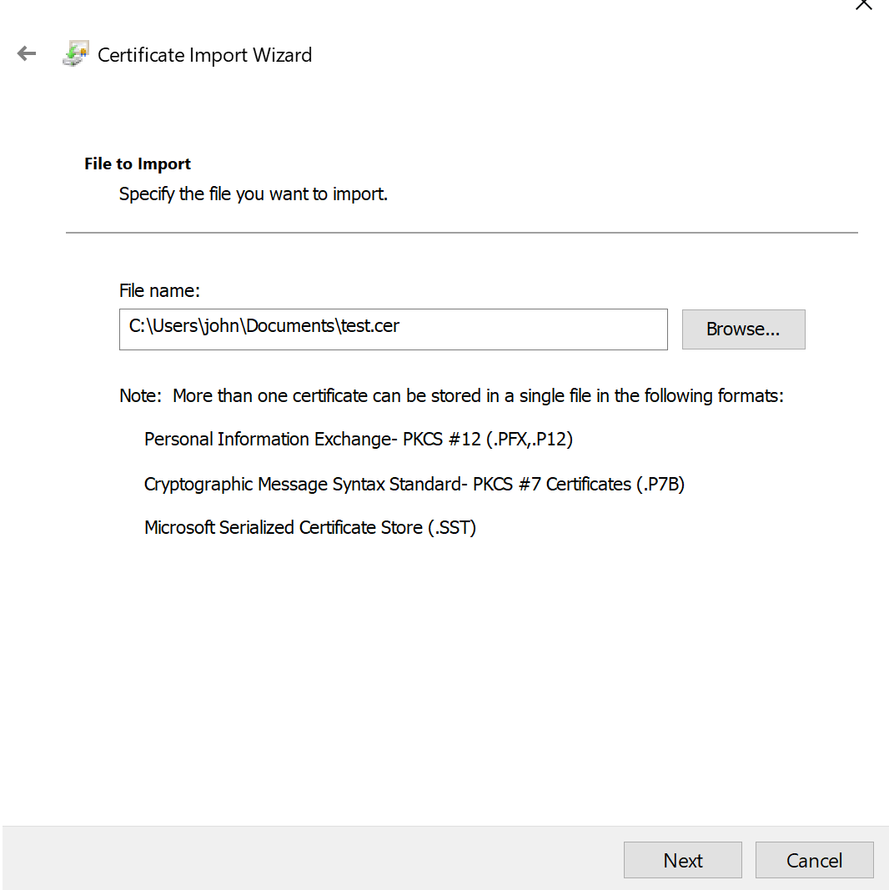

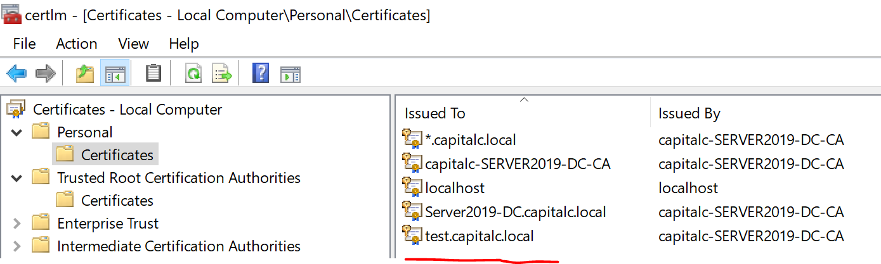

Export the certificate from Personal store to a *.pfx file:

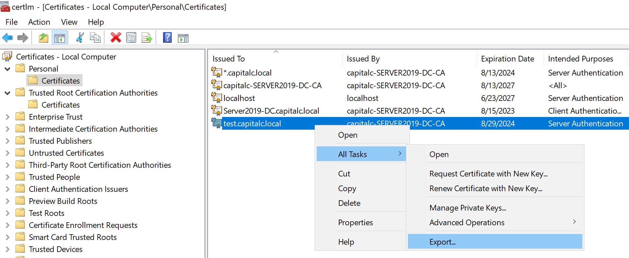

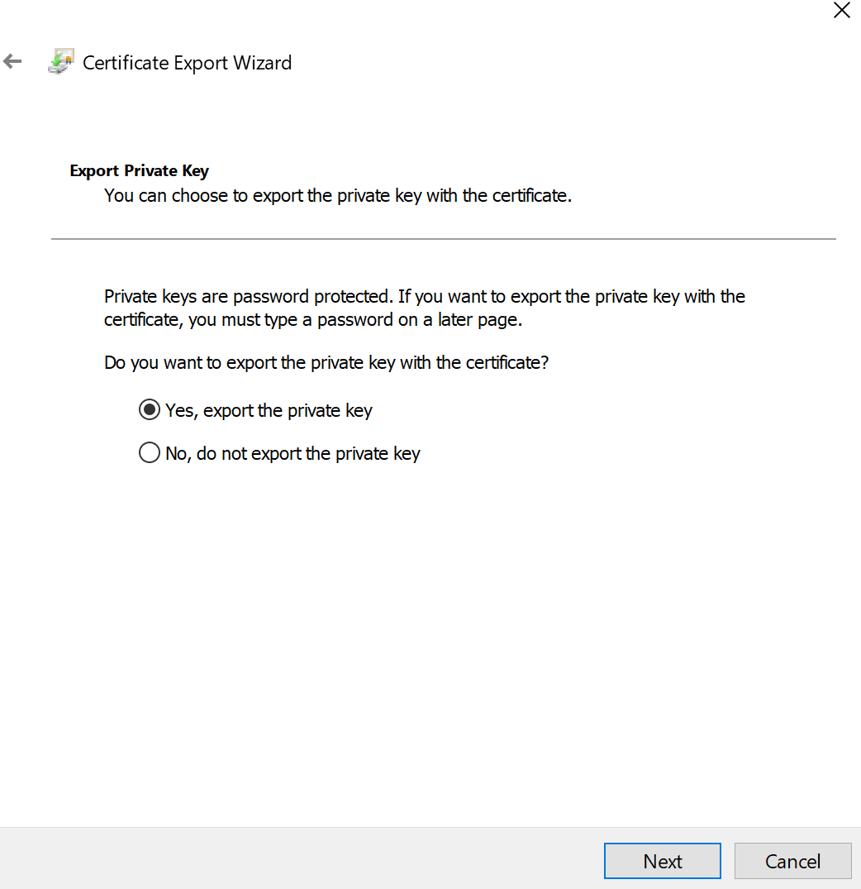

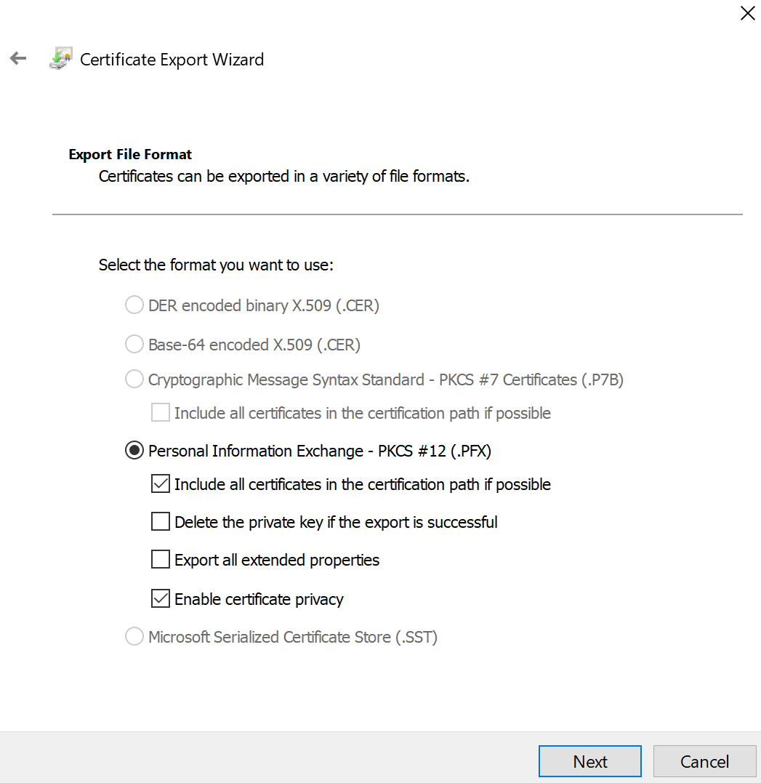

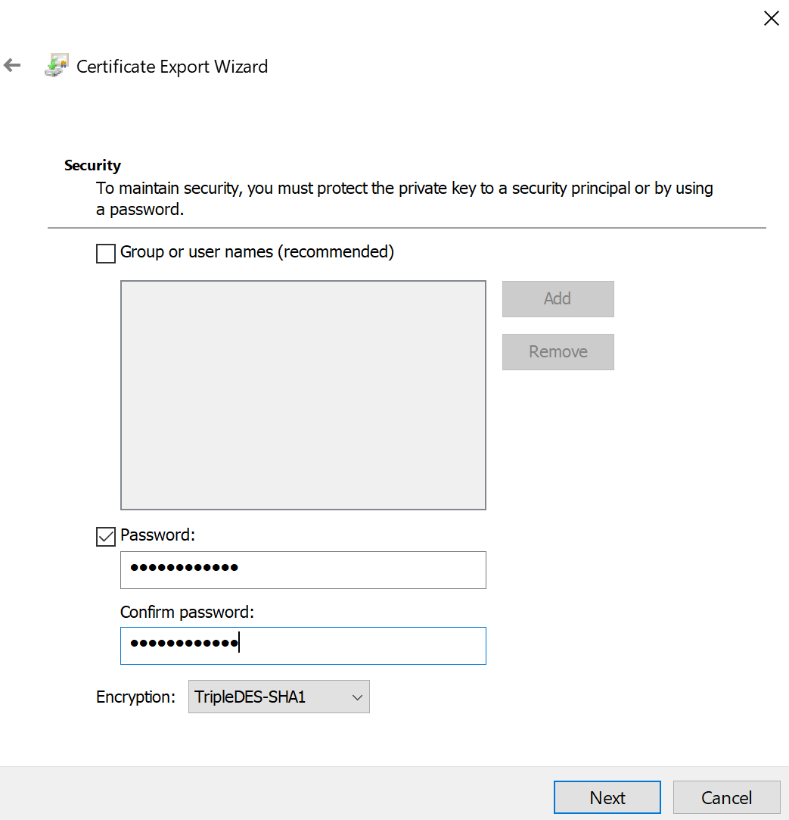

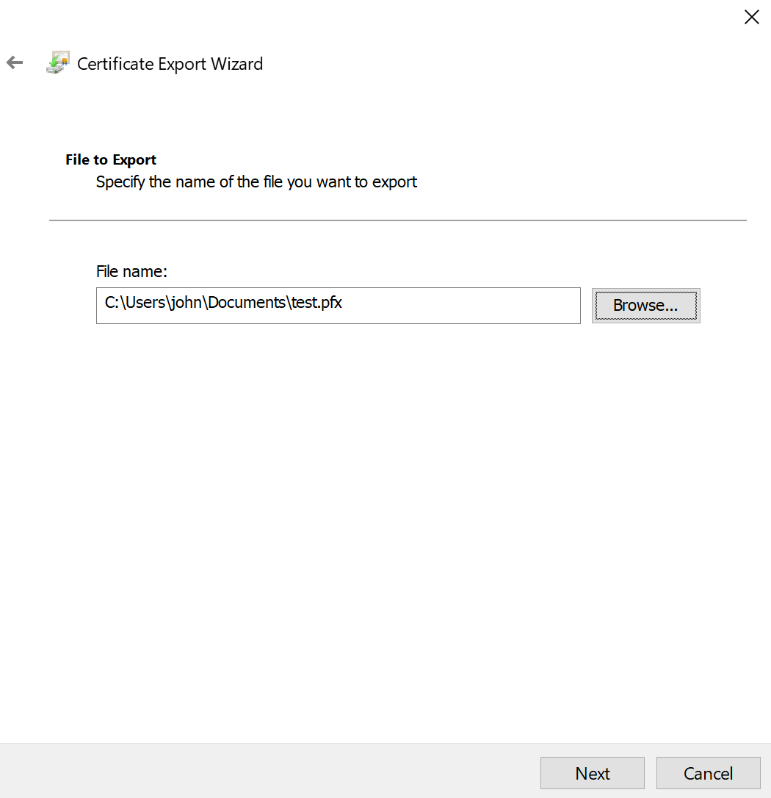

Import the web site certificate to IIS:

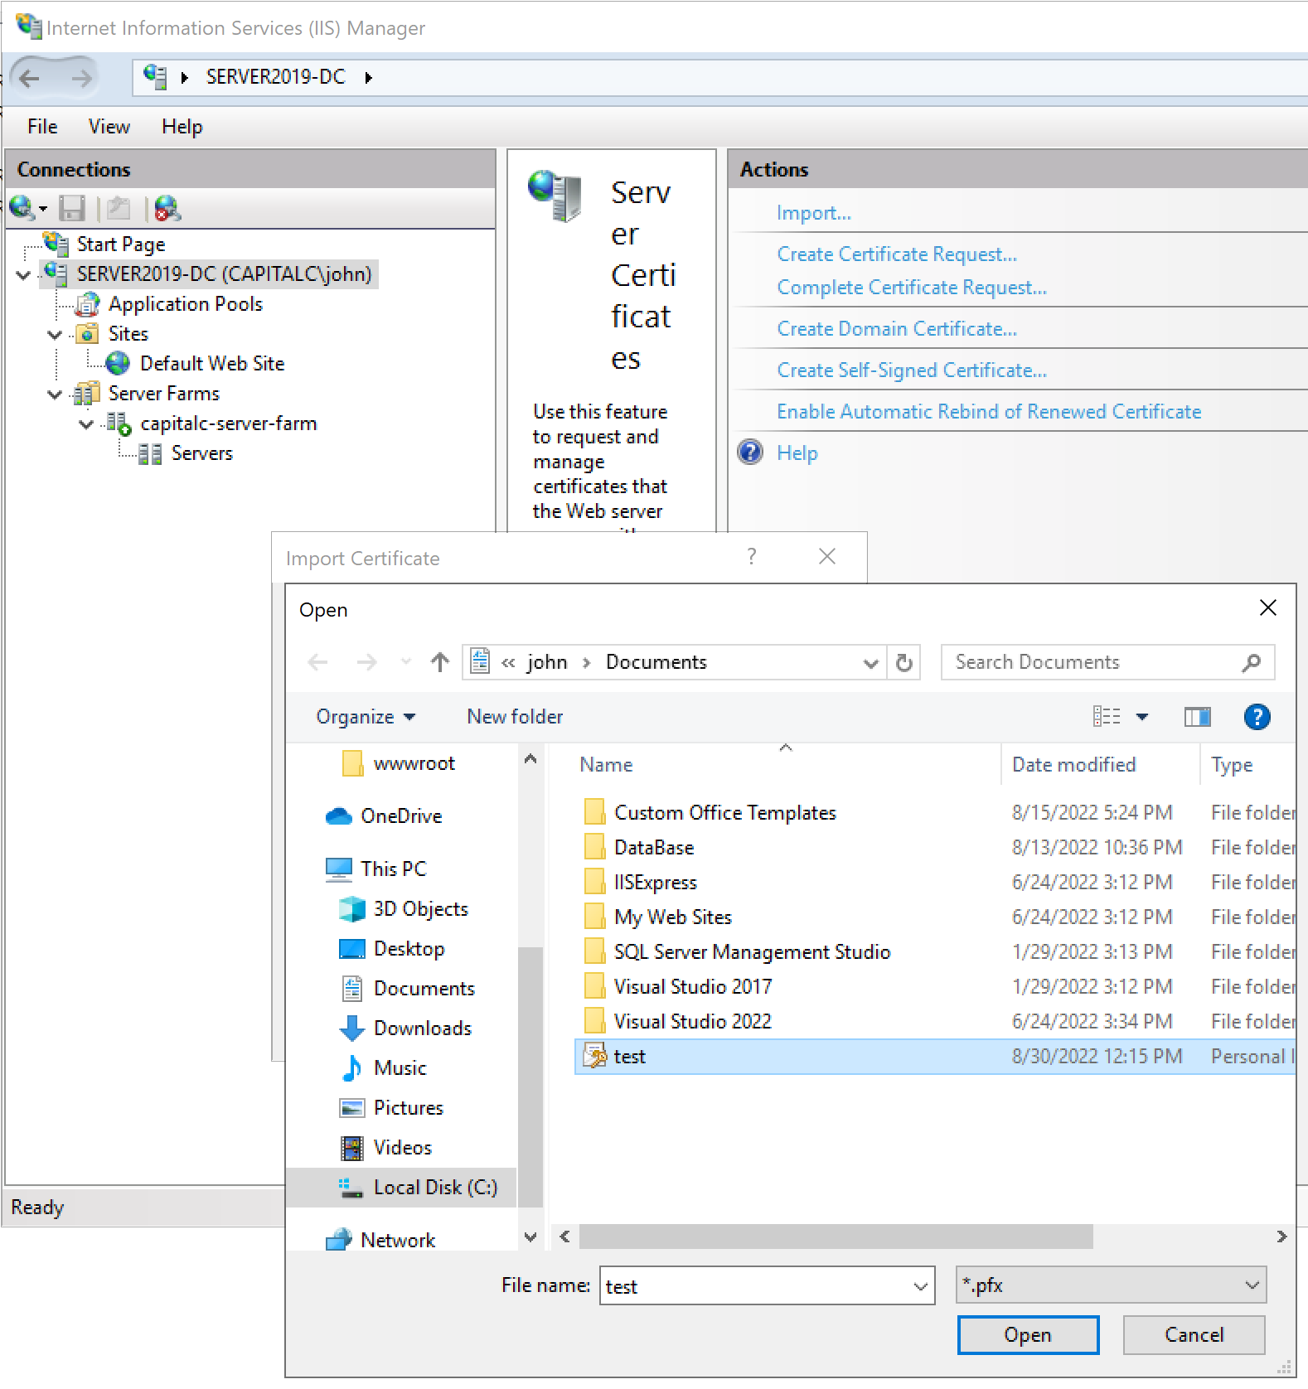

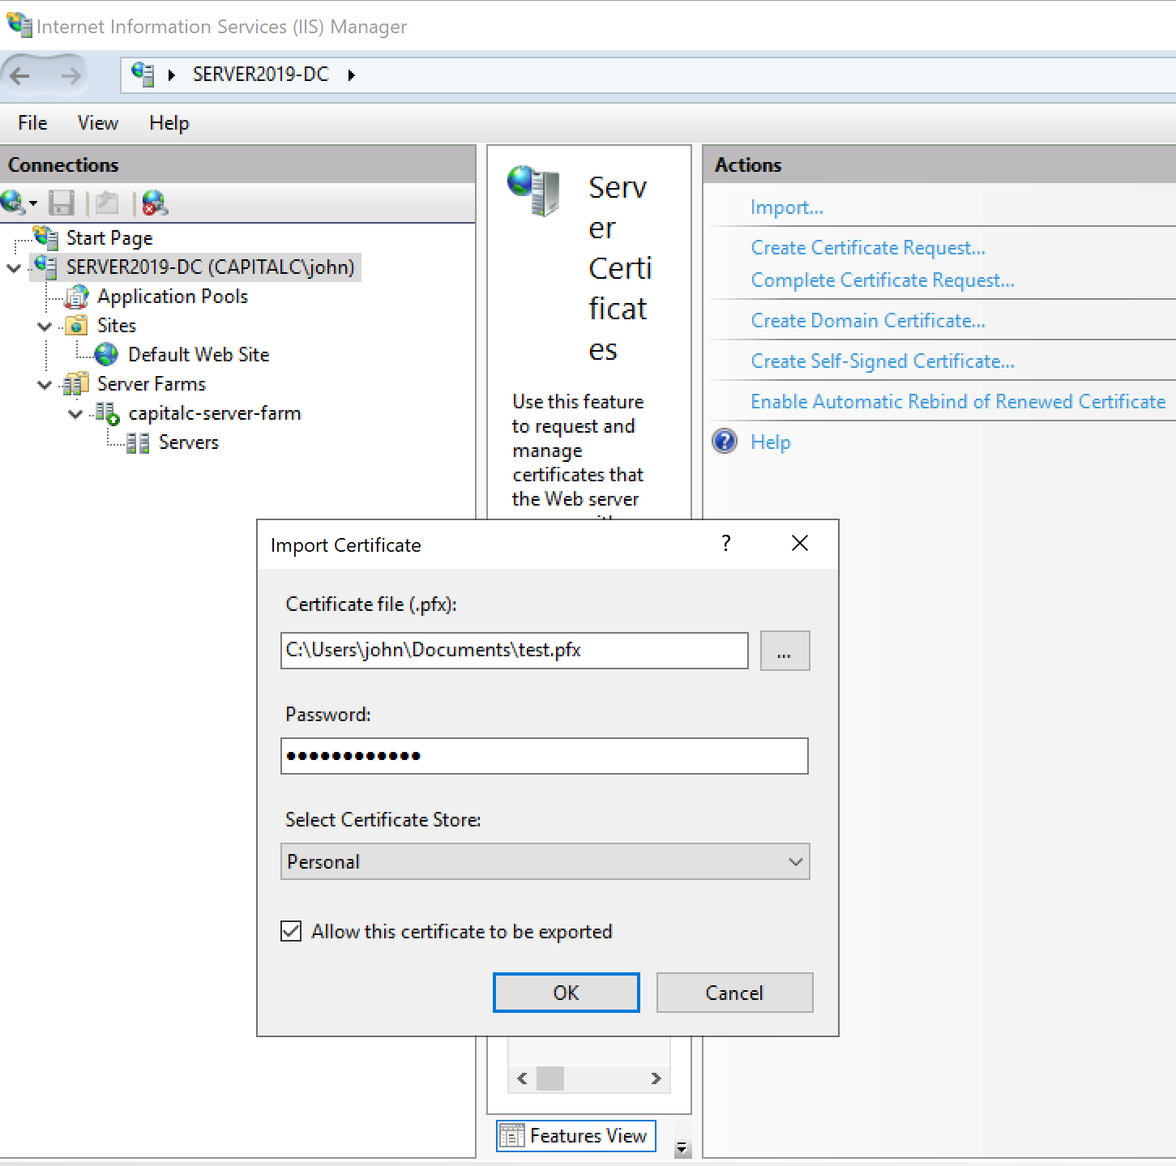

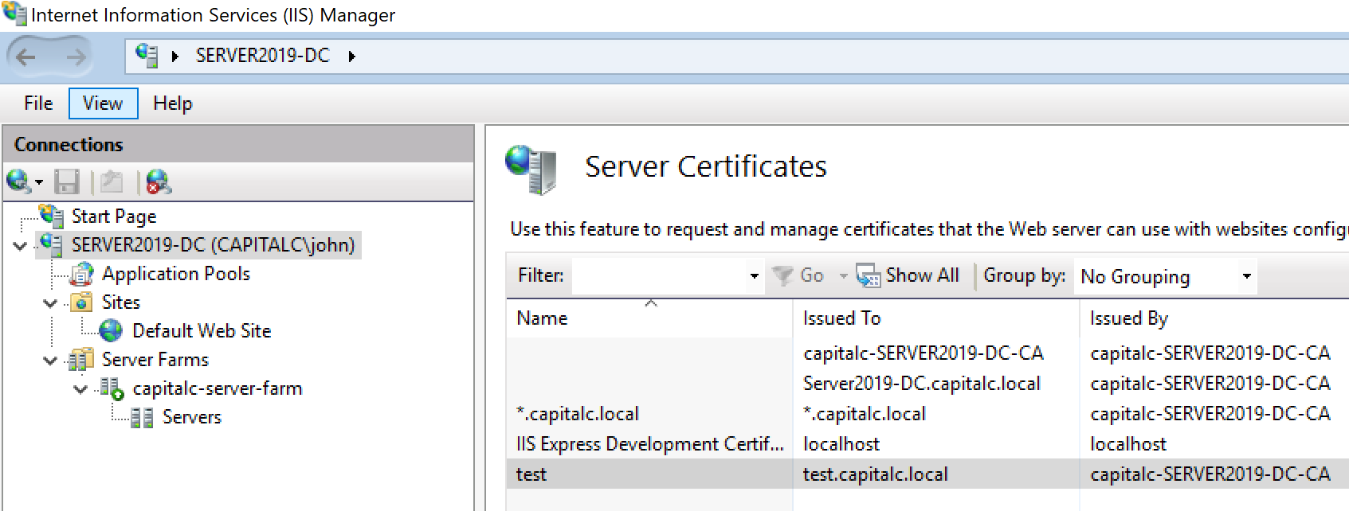

Pick a certificate for a web site:

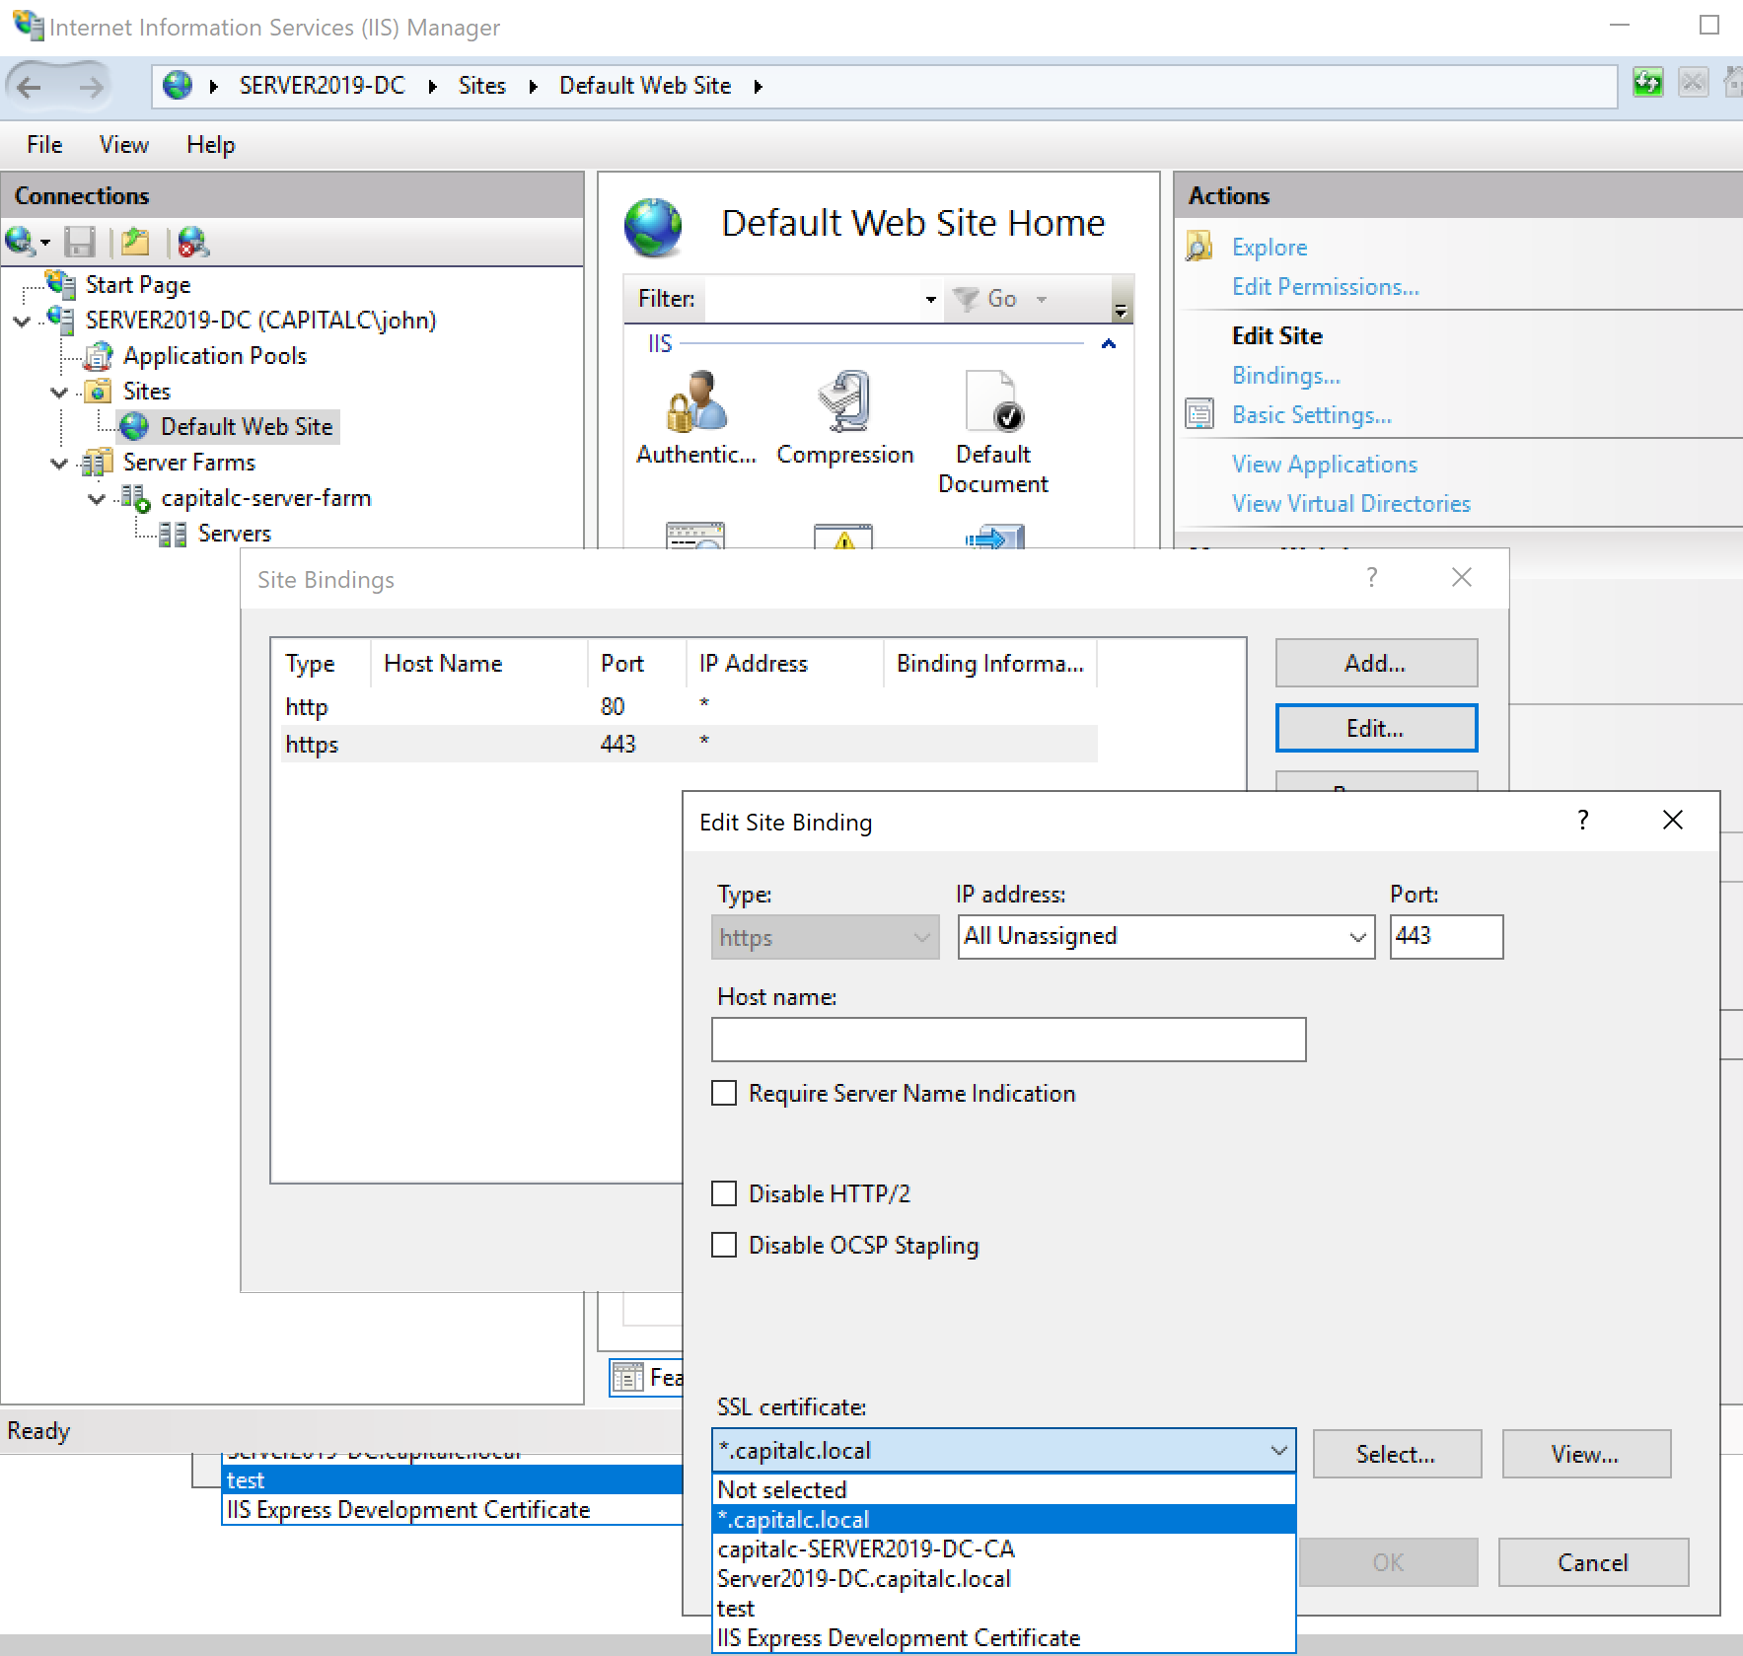

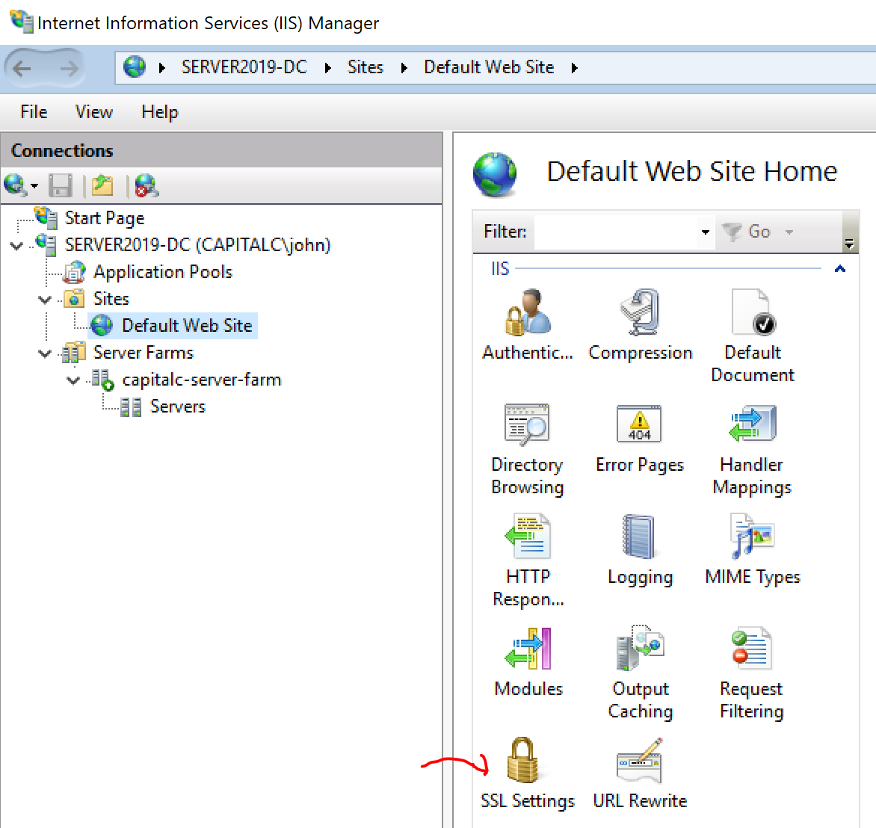

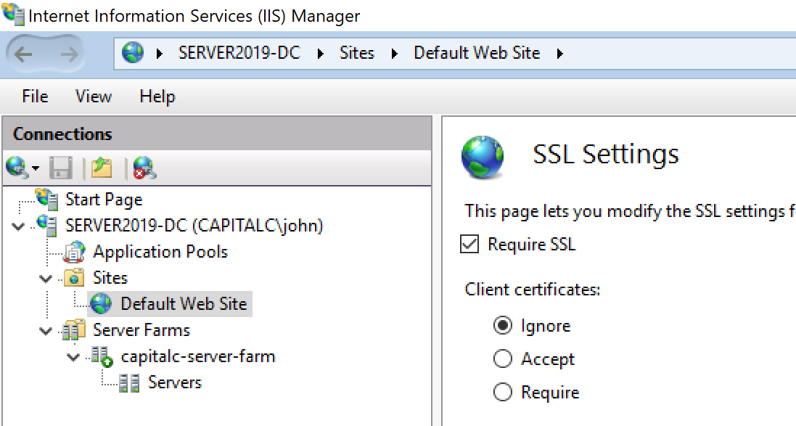

If “Required SSL” is checked it means user has to use https, if type http:// there will be an error reported from the browser.

URL Rewrite is used to redirect http:// to https:// automatically. This also works in the ARR setting, all the http:// requests to NLB server farm (in our case is Server2019-DC.capitalc.local) will be redirected to use https:// automatically.

